
Name = Muhammad Daniyal
Registration no = 24371
Datye : 22?06/2026
Teacher : Mam Faryal

Lab 12

Polymorphism

Lab Tasks

Task 1:
  - Create two area() functions in the same class:
    - One for square
    - One for rectangle
  - Demonstrate compile-time polymorphism.

Input/output:
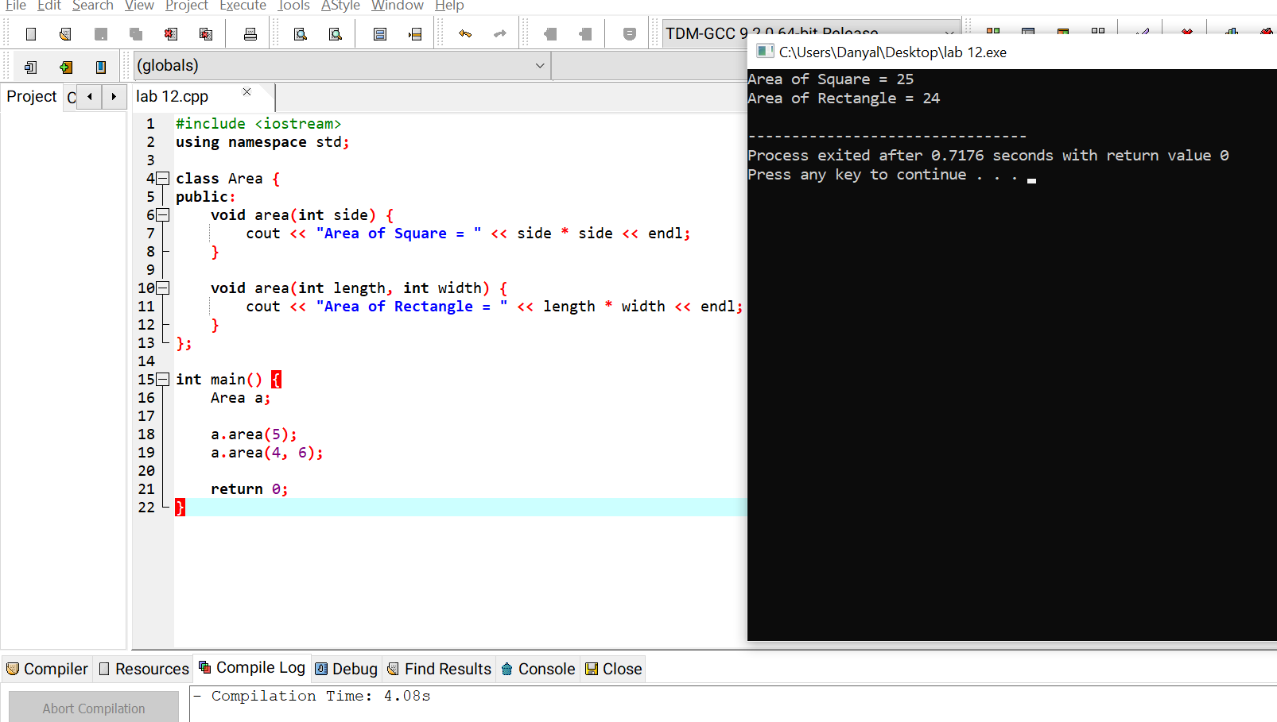

Task 2:
  - Remove the keyword virtual from base class.
  - Observe the output.
  - Write the difference in output.
Input/output:

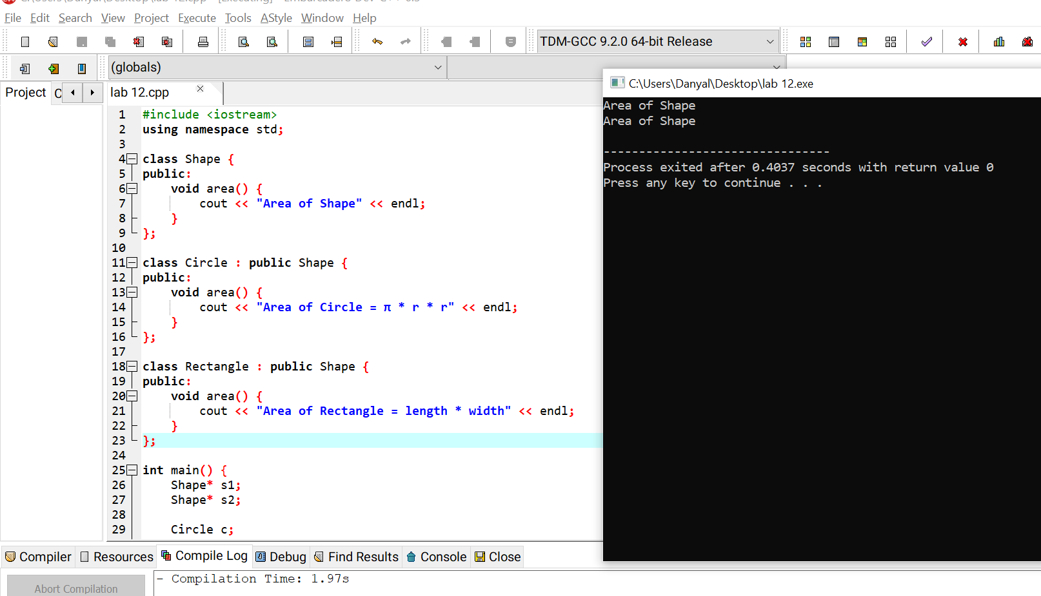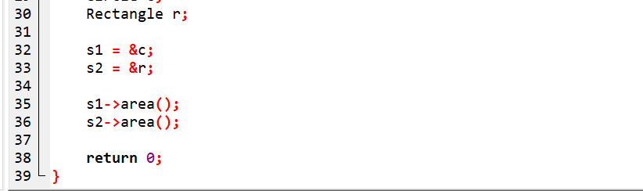

Task 3:
  - Create a new derived class Triangle.
  - Override area() function.
  - Display triangle area formula.

Input/output:
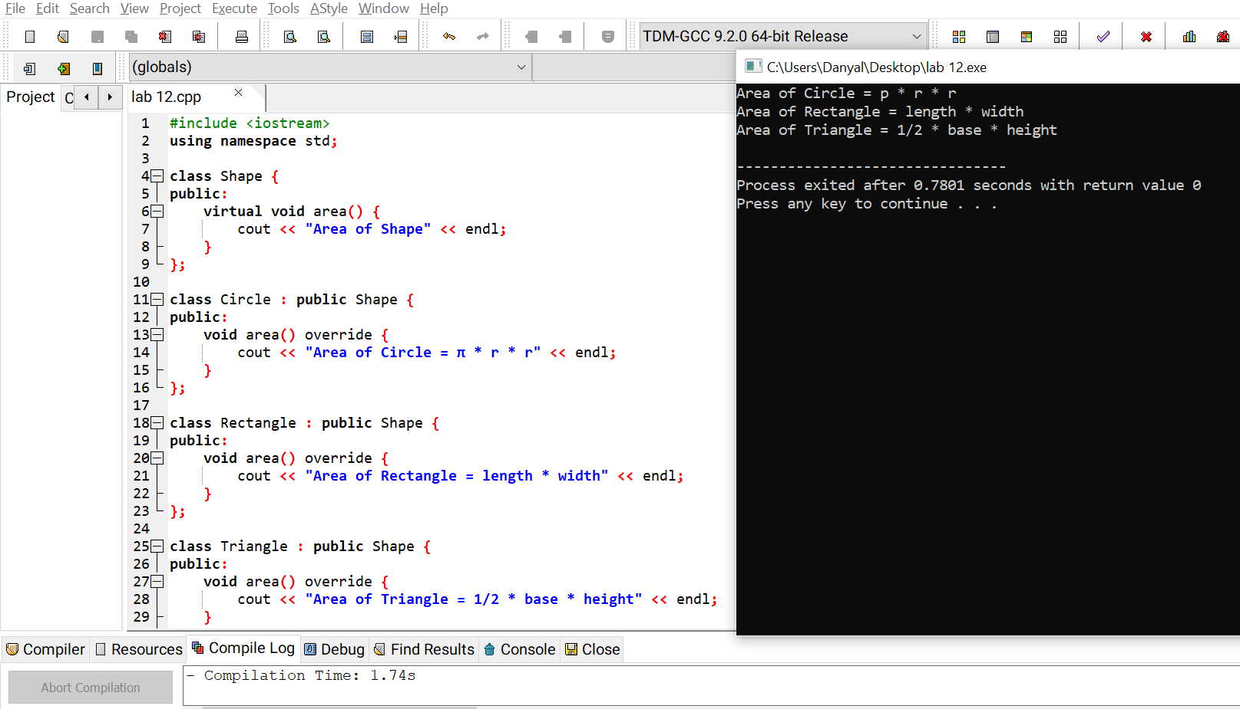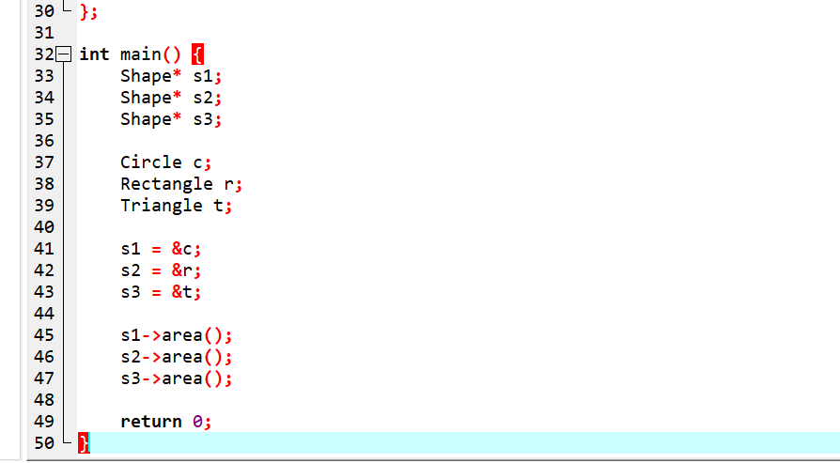

Task 4:
  - Explain the difference between:
    - Function Overloading and Function Overriding
    - Compile-time and Run-time polymorphism

GitHub Commands
git add lab12-polymorphism.cpp
git commit -m "Lab 12 Polymorphism" git push
Task 4: Differences
Function Overloading:
  - Function overloading means having the same function name with different parameters.
  - It happens in the same class.
  - It is a type of compile-time polymorphism.
  - It does not require the `virtual` keyword.

Function Overriding :
  - Function overriding means a derived class provides its own version of a base class function.
  - It happens between base and derived classes.
  - It is a type of run-time polymorphism.
  - It requires a `virtual` function in the base class.

Compile-Time Polymorphism
  - It is resolved during compilation.
  - It is achieved using function overloading.
  - It is faster because the function call is decided early.

Run-Time Polymorphism:
  - It is resolved while the program is running.
  - It is achieved using function overriding.
  - It uses virtual functions to decide the function call at runtime.

